Garellek 2016:

* Voicing contrasts exist in a three-dimensional space rather than just a one-dimensional continue from breathy to modal to creaky (8):

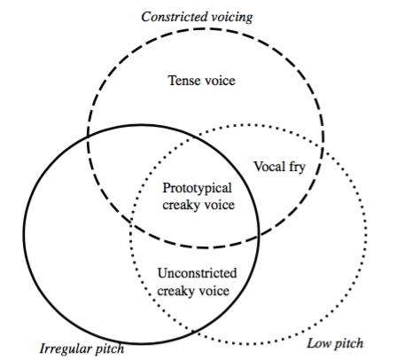

* The acoustic and articulatory aspects of voice quality only matter if they are perceptible (10).
* Relevant acoustic measures from Kreiman 2014:
  + “Inharmonic”/noise component: HNR
  + Harmonic source (before filtering)/spectral slope: H1-H2, H2-H4, H4-H2 kHz, H2 kHz-H5 kHz
    - H4-H2 kHz: difference between fourth harmonic and the harmonic closest to 2000 Hz
  + Temporal components of the voice source: f0 tracking, amplitude tracking
  + Vocal tract transfer function (the filter that acts on the source): formant frequencies and bandwidths, spectral zeroes and bandwidths (11)
* Summary of different types of voice quality as compared with modal voice: (21):
  + Breathy voice:
    - Higher H1–H2, H2–H4, H4–H2 kHz, H2 kHz–H5 kHz Lower HNR
  + Prototypical creaky voice:
    - Lower H1–H2 H2–H4, H4–H2 kHz, H2 kHz–H5 kHz Lower HNR
    - Lower f0
  + Unconstricted creaky voice:
    - Higher H1–H2 H2–H4, H4–H2 kHz, H2 kHz–H5 kHz Lower HNR
    - Lower f0
  + Vocal fry:
    - Lower H1–H2 H2–H4, H4–H2 kHz, H2 kHz–H5 kHz No difference in HNR
    - Lower f0
  + Tense voice:
    - Lower H1–H2 H2–H4, H4–H2 kHz, H2 kHz–H5 kHz No difference in HNR
    - Higher f0

Keating, Garellek, and Kreiman 2015:

* Different types of creaky voice and their acoustic correlates:

|  |  |  |  |  |  |
| --- | --- | --- | --- | --- | --- |
| Property | Low f0 | Irregular f0 | Glottal constriction | Damped pulses | Subharmonics |
| Main correlate | Low f0: (4)   * STRAIGHT is “robust in the face of F0 irregularity” * SHR pitch tracking is good for detecting multiply pulsed creak) * Lowering F0 may lower CPP | High noise:   * Low HNR (except for vocal fry, which has a relatively high HNR) | Glottal constriction:   * Low H1*-H2* | Low noise, narrow bandwidths:   * Low B1 values * High HNR | High SHR (only for multiply pulsed creak) |
| Type | | | | | |
| Prototypical | Yes | Yes | Yes |  |  |
| Vocal fry | Yes |  | Yes | Yes |  |
| Multiply pulsed |  | Yes | Yes |  | Yes |
| Aperiodic | No | Yes | Yes |  |  |
| Nonconstricted | Yes | Yes | No |  |  |
| Tense | No |  | Yes |  |  |

Interesting syllabification resource: K. Gorman, “Generative phonotactics,” Ph.D. dissertation, University

of Pennsylvania, 2013. (cited in Garellek and Seyfarth 2016)

Garellek and Seyfarth 2016:

* Phrasal creak: “prolonged irregular voicing, often at edges of prosodic phrases” (1)
* Coda /t/ glottalization: e.g. producing a glottal stop at the end of “about”/alveolar closure in syllable-final /t/ is produced at the same time as glottal constriction (or glottal constriction replaces it entirely) (1)
* CPP found to be helpful in distinguishing between /t/ glottalization and phrasal creak (1)
* Phrasal creak can persist for much longer than creak from /t/ glottalization (e.g. over several words or the entire end of a prosodic phrase rather than just the coda /t/ of a single syllable (1)
* /t/ glottalization and phrasal creak may co-occur in a single word (1)
* How they selected words with a coda /t/: (2)
  + Samples had to be at least 50 ms long
  + Samples must be a [t] or a [glottal stop]
* How they identified phrasal creak: (2)
  + Phrasal creak = “ a period of irregular voicing that lasted for at least twice the duration of the target vowel preceding the syllable-final /t/”
* Acoustic measures of creaky voice relative to modal voice: (2)
  + F0 (STRAIGHT): irregular
  + Measures of noise:
    - CPP: lower
    - HNR05: lower
    - SHR: higher
  + Spectral tilt
    - H1*-H2*, H2*-H4*, H1*-A1*, H1*-A2*, H1*-A3*, H4*-2K*, 2K*-5K*
* How they excluded samples with invalid F0 measurements:
  + Excluded samples where the F0 in one analysis frame was half or double that in the previous frame since octave jumps indicate invalid F0 measurements (?) (2)
  + Not entirely clear how they did this, but, “Second, we standardized F0 within two groups within each speaker: modal [t] tokens, and tokens with phrasal creak and/or glottalization.” (2)
* Linear discriminant analysis:
  + Finds a linear combination of predictors that result in the best separation of two or more groups (3)
  + For each acoustic measurement, included two predictor variables: the change from the first third to the last third of the segment and the average value over the segment (since they though that the change might be the best predictor of a glottal stop) (3)
  + CPP: good at discriminating glottal stop (3)
  + Spectral tilt and low F0: good markers of (4)
  + SHR did not help to distinguish between different types of creaky voice (4)